Cassini Subsystem

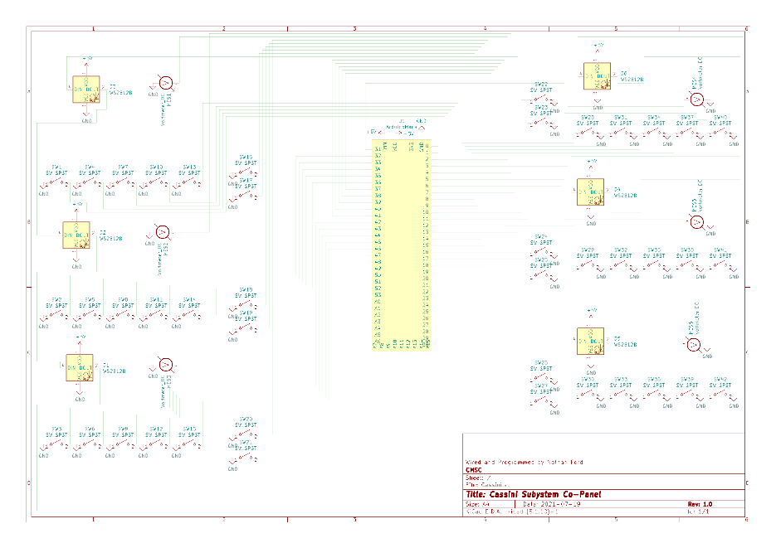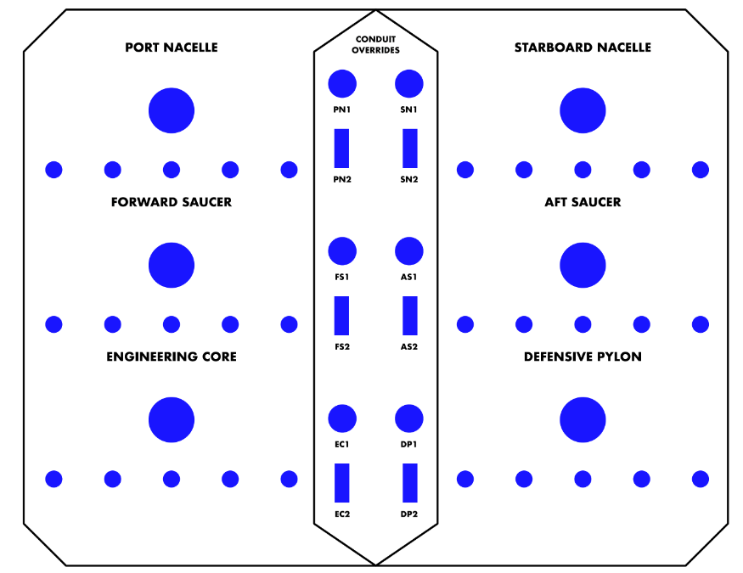Co-Panel

* Backlights/Volt Meters
* Switches

Backlights and Volt Meters

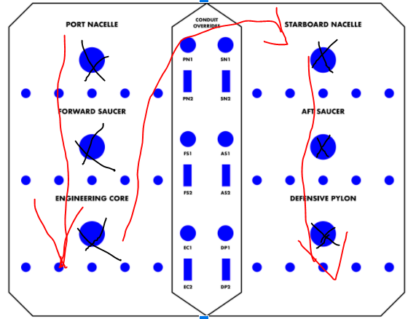These are the mediums of which the panel can communicate to the user and are the easiest things to wire on these panels.

1. Backlight Neo Pixels – We decided to put backlights behind each gauge that will show a different color based on the gauge value, and we used neo pixels for this. These are daisy chained top to bottom from left to right, refer to the picture to the right, each X represents a backlight, and the red arrows show in what order to wire them. The pixels require 5v and GND going to each one and pin 13 on the Arduino is connected to the Neo Pixel in the top left corner.

|  |  |
| --- | --- |
| **Voltmeter Position** | **Arduino Pin** |
| Top Left | 2 |
| Top Right | 3 |
| Middle Left | 4 |
| Middle Right | 5 |
| Bottom Left | 6 |
| Bottom Right | 7 |

1. 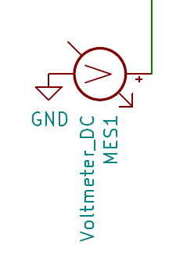Now for your volt Meters, each one of them has a positive and negative side, hook the negative side to GND and take the positive side and hook it to the desired pin on the Arduino.

For the volt meters if you are replacing one or building a new one and accidentally cut circle holes instead of oval like we did, it is important to file down the side bumps, so your gauge sits more level to the panel.

Also, you may find this funny, for those of you do not know, the Arduino has dedicated Analog and Digital Pins on it, but these are for inputs, and for outputs, if you want to have an analog signal out, you must use pulse width modulation on a digital pin for the closest approximation XD.

Switches

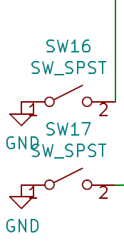 Now that we have the backlights and voltmeters wiring out of the way we get to do the switches wiring!!!! If you could not tell by the rat’s nest of wires on the schematic, this is the “Fun” part of making these panels.

1. Multiply pins – These are those two SPST (Single Pull Single Throw) switches off to the side of each gauge, they do special functions depending on the gauge. They have one side connected to GND and the other side to the Arduino, it does not matter which side is ground.

|  |  |  |
| --- | --- | --- |
| **Gauge Position** | **Switch 1 Arduino Pin** | **Switch 2 Arduino Pin** |
| Top Left | 8 | 9 |
| Top Right | 10 | 11 |
| Middle Left | 14 | 15 |
| Middle Right | 16 | 17 |
| Bottom Left | 18 | 19 |
| Bottom Right | 20 | 21 |

1. The Addition Pins – I am not sure what else to call them, they add values to the gauges, so that is what I am going to call them. If you cannot tell from my other documentations and codes, I do not remember their names from the fronts of the panels most of the time, so I make up my own names, hopefully this is not a problem down the road XD. For these switches they are also SPST switches that have one side to ground and one to a pin on the Arduino.

|  |  |  |  |  |  |
| --- | --- | --- | --- | --- | --- |
| **Gauge Position** | **SW 1 Pin** | **SW 2 Pin** | **SW 3 Pin** | **SW 4 Pin** | **SW 5 Pin** |
| Top Left | 22 | 23 | 24 | 25 | 26 |
| Top Right | 27 | 28 | 29 | 30 | 31 |
| Middle Left | 32 | 33 | 34 | 35 | 36 |
| Middle Right | 37 | 38 | 39 | 40 | 41 |
| Bottom Left | 42 | 43 | 44 | 45 | 46 |
| Bottom Right | A8 | A9 | A10 | A11 | A12 |

